Materialized view
Before Studing materialized view ,just buffer your triggers and views concept of dbms.
It Is different from view that we know in sql.
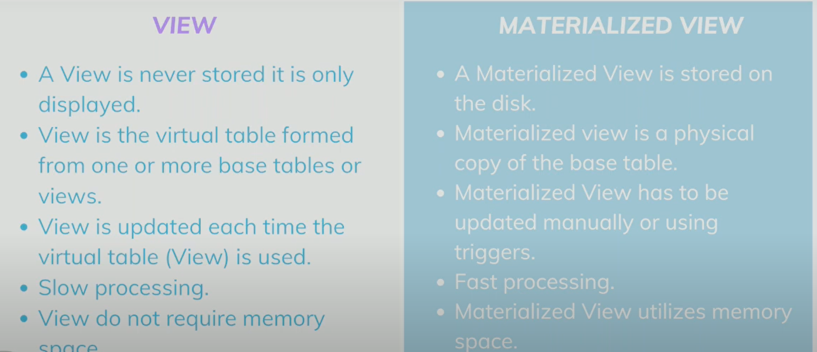
Materialized view is a pre-computed data set derieved from query specification(ie select…) and is stored for future use.
It uses expensive aggregation,projection, so that it run faster in large data set.
DDL COMMAND:-
- Create materialized view
- drop materialized view
- describe materialized view
- alter materialized view
- show materialized view
DCL command can be viewed in materialized view
DCL command:-
Grant:- to access the privileged to user
Revoke:-to get back the access privileges from user
Syntax of materialized view
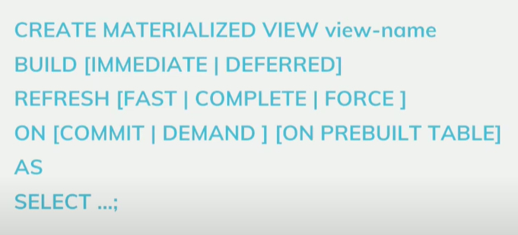

Terms of above syntax:-
Immediate:- data to be populated immediately
Deffered:- data to be populated with some seconds of refresh.
Types of refresh:-
Fast
Fast refresh is attempted ,if materialized view table are not present against source table,creation fails
Complete
Repopulated the truncate view using associate query.
Force
Force to perform fast refresh ,if not possible then complete refresh is performed.
Refresh is triggered by :-
on commit
Triggered by commited data which is dependent on a table as a source.
on demand
Triggered by initial request or a scheduled task.

